INTRODUCTION:

Vampire electricity is a way through which electricity is lost even when devices are not being used. The project I am designing primarily reduces energy wastage through mobile phone overcharging and mobile phone chargers, which are vampire devices. I also evaluate the scope of a similar device in other vampire devices such as laptops and TVs. According to Stanford Magazine, vampire electricity from phones and phone chargers alone could waste around 4 billion USD per year. Therefore, addressing this problem with a view to improving sustainability is important.

CIRCUIT DESIGN TO SAVE ELECTRICAL ENERGY:

<https://www.desmos.com/calculator/ngu8unsd0n> Graph where I collected data.

In order to find out the current drawn by the mobile phone battery while charging, I used a multimeter and noted down modal current values in terms of distribution of durations in a single integral change in charge percentage. As can be observed, current drawn falls below 0.500 A only after the phone has been 94% charged. This data was collected from a Samsung Galaxy A31 with a typical battery capacity of 5000 mAh using a JTP adaptive fast charger with the following specifications:

INPUT: AC100-240V 50.60Hz 0.5A

OUTPUT: 3.6V-6V = 3A/ 6V-9V = 2A/ 9V-12V = 1.5A

POWER: 18W

.

Using the same charger for an Iphone 8, the current drawn was around 1.600 A when the phone was 0% charged, while it was around 0.400 A when the phone was 100% charged.

Another important thing I observed was that the current drawn decreased to around 0.600 A when the phone was being used. Possible reasons may include reduction of current to increase safety for users.

Therefore, the threshold value chosen for the device to switch of the current was 0.450 A.

Another observation made in order to calculate the energy saved is made in the following graph.

<https://drive.google.com/file/d/1AvKPRLvqdvEdfX0QQnxX_0IIJblkTF6q/view?usp=sharing>

As can be seen, the average current in the first 15 minutes after the phone is 100% charged is around 0.152A. The average after these 15 minutes drops to around 0.037A. Let t2 be the time in hours for which the phone is charging after 100%. Let t1 be the time taken for the phone to completely charged. This was found to be at an average of about 3 hours.

$$∴{Energy consumed without device E}_{1}=V\left(I_{1}t_{1}+I_{2}t_{2}\right)$$

$$∴Energy consumed with device E_{2}=VI_{1}t_{1}+P_{ON}t_{1}+P_{OFF}t_{2}$$

$$∴Energy saved E_{4}=\left(E_{1}-E_{2}\right)=V\left(I_{1}t_{1}+I_{2}t_{2}\right)-\left(VI_{1}t_{1}+P_{ON}t_{1}+P_{OFF}t_{2}\right)=VI_{1}t_{1}+VI_{2}t_{2}-VI_{1}t_{1}-P_{ON}t_{1}-P_{OFF}t_{2}=VI_{2}t_{2}-P_{ON}t_{1}-P_{OFF}t_{2}=t_{2}\left(VI_{2}-P_{OFF}\right)-P_{ON}t_{1}$$

$$t_{1}=3h$$

$$VI_{2}t_{2}=\left(9.150×0.152×0.25\right)+\left(9.150×0.037×4.75\right)=1.96Wh$$

For an average charging time of 8 hours, given that this is the approximate average sleeping time for teenagers and young adults, $t_{2}=5h$.

The circuit diagram below shows the initial circuit I designed for the device. It uses an ACS712 20A current sensor to derive current from the voltage. It uses an SPDT relay in order to act as a switch triggered by the Arduino Uno.

The $E_{4}=t_{2}\left(VI_{2}-P_{OFF}\right)-P_{ON}t_{1}=1.96-\left(0.541×3\right)-\left(0.103×5\right)=-0.178Wh$

Therefore, there is an energy wastage of around $0.178Wh$. The following problem was observed when using non- extra heavy duty $9V$ battery or cell.

<https://drive.google.com/file/d/1AvKPRLvqdvEdfX0QQnxX_0IIJblkTF6q/view?usp=sharing>

In order to try to save electrical energy, I replaced the SPDT relay with a P- channel MOSFET and used the following circuit.

The $E_{4}=t_{2}\left(VI_{2}-P_{OFF}\right)-P_{ON}t_{1}=1.96-\left(0.314×3\right)-\left(0.103×5\right)=0.503Wh$

Therefore, the energy saved is around $0.503Wh.$ This amount of energy is much lower than previously anticipated. Given the trickle charging feature of modern smartphones, the energy consumed after charging is small, thereby causing the energy saved to be small as well. This lead me to focus on uses that I first considered secondary.

These are stated below:

1. SAFETY:

It has been long observed that cell phone batteries when overcharged cause heating of the battery and of wires, maybe resulting in a fire in some cases.

( <https://pubs.rsc.org/en/content/articlelanding/2016/cp/c6cp00887a#!divAbstract> )

From the above diagram, taking c of Lithium- ion battery= 900 $Jkg^{-1}K^{-1}$

Assuming a room temperature of 293K ( <https://www.nist.gov/pml/weights-and-measures/si-units-temperature>, ),

This model predicts a large increase in temperature. However, the actual temperature increase may be lower as heat may be dissipated to the surroundings. Still, trickle charging will compromise safety by causing plating of the metallic lithium in the battery ( <https://batteryuniversity.com/index.php/learn/article/charging_lithium_ion_batteries> )

The cell pressure rises and if the charge is allowed to continue, the current interrupt device (CID) responsible for cell safety disconnects at 1,000–1,380kPa (145–200psi). Should the pressure rise further, the safety membrane on some Li-ion bursts open at about 3,450kPa (500psi) and the cell might eventually vent with flame. ( <https://batteryuniversity.com/index.php/learn/article/charging_lithium_ion_batteries> ) The threshold temperature at full charge is .

<https://www.accurateampere.co.in/li-ion-batteries.html>

<https://batteryuniversity.com/learn/article/confusion_with_voltages> For $V_{2}$.

1. BATTERY LIFE:

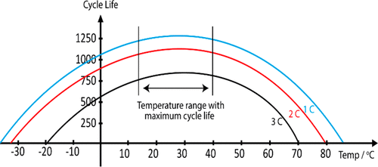

Figure 2. Effect of ambient temperature on LIB cycle life. ( <https://pubs.acs.org/doi/10.1021/acsenergylett.9b00663> )

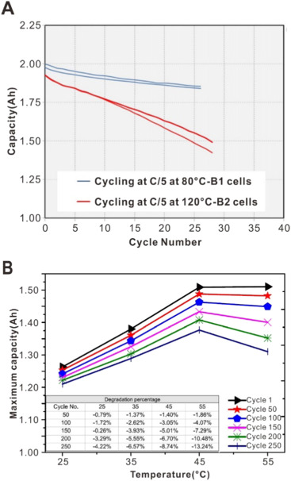

Fig. 5. (A) Capacity change with cycle number of batteries cycling at C/5 rate at 85 °C and 120 °C, respectively. B1 cells: After two initial cycles at 60 °C, the cells were cycled at 85 °C between 2.7 V and 4.1 V for 15 days; B2 cells: After two initial cycles at 60 °C, the cells were cycled at 120 °C between 2.7 V and 4.1 V for 15 days. (B) Maximum capacity change and degradation percentage of the tested LIB with temperature after various cycle numbers. ( <https://www.sciencedirect.com/science/article/pii/S1002007118307536> )

Battery life will decrease with overcharging due to increase in ambient temperature.

ENERGY SAVING UPDATE:

I saw that much more energy is in fact saved. According to the following data from <https://standby.lbl.gov/data/summary-table/> and from information from the Stanford Magazine, saves enough energy a year to power a coffee maker for around 10 to 11 days continuously ( <https://stanfordmag.org/contents/vampire-energy-essential-answer> .) Energy saved per year per person from overnight charging can be around 3.6 kWh from phone chargers alone. This would mean that for 760 mobile phone users in India in 2021, around 2,700 GWh per year, which is equal to around 78% the energy output per year of a standard 500 MW coal- based thermal power plant ( <https://www.mcginley.co.uk/news/how-much-of-each-energy-source-does-it-take-to-power-your-home/bp254/> .)

For laptops, energy saving can be around 20 times as much.

|  |  |  |  |  |
| --- | --- | --- | --- | --- |
| **Charger, mobile phone** | | | | |
| On, charged | 2.24 | 0.75 | 4.11 | 4 |
| On, charging | 3.68 | 0.27 | 7.5 | 23 |
| Power supply only | 0.26 | 0.02 | 1 | 32 |

s